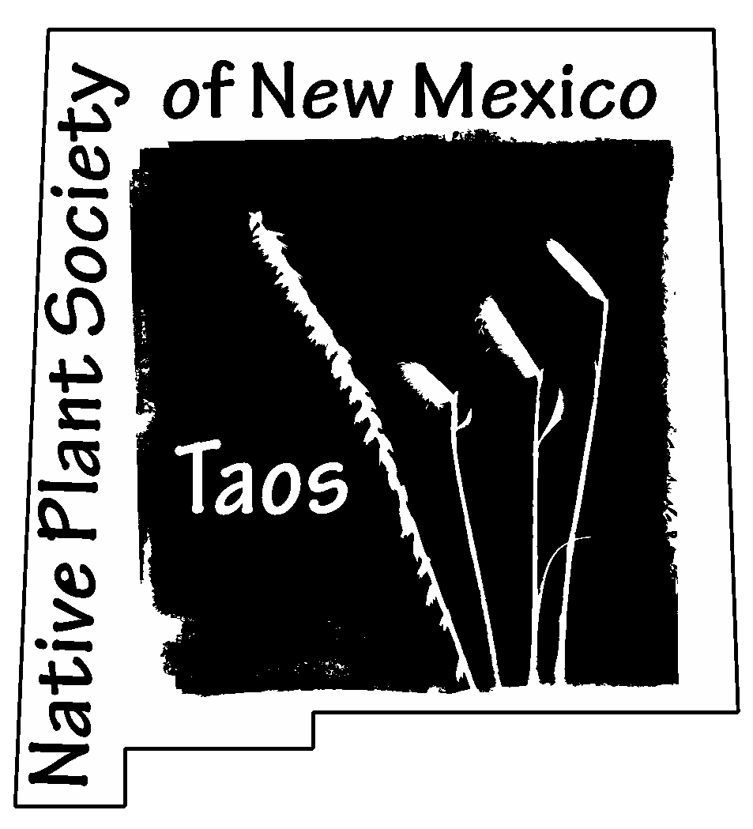
The Taos Chapter of the Native Plant Society of New Mexico
2024 NPSNM State Conference

What
- The Taos Chapter of the New Mexico Native Plant Society (NPSNM) is hosting a state-wide meeting in Taos, July 26-28, 2024.

Why we ask for your support
- We expect about 150 Taoseños and visitors from throughout the state who will be a great audience for your business.
- You’ll be supporting the mission of the NPSNM: educating the public about native plants, fostering conservation, preserving natural habitats, and encouraging use of native plants to conserve water, land, and wildlife.
Please donate at a level comfortable to you / your organization:
$500+ Ponderosa Pine supporters
$100-$499 Aspen supporters
$50-$99 Piñon Pine supporters
_________ Other

In appreciation of your support, your business (or personal) name will be listed in various media, on a sheet given to each attendee, and during the 3-day event. Please send your logo to the email below.
taosnps@gmail.com OR rbpokorney@gmail.com. For more information, contact Bob Pokorney at (928) 451-6942 or visit our website, www.npsnm.org‬‬
Checks, made out to NPSNM-Taos Chapter, should be mailed to:
Jan Martenson/NPSNM-Taos treasurer
73 Vista Linda Rd
Ranchos de Taos, NM 87557

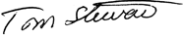
Please retain this document for your records. It is necessary for any federal income tax deduction for this contribution. The Native Plant Society of New Mexico is a 501(c)(3) non-profit organization, EIN 85-0249915. The Society has not provided you with any goods or services in exchange for your contribution of $_______________ on _________________, 2023.
Tom Stewart, Treasurer, NPSNM
✂- - - - -- - - - - - - - - - - - - - - - - - Return this lower portion with check - - - - - - - - - - - - - - - - - - - --
For NPSNM / Taos Chapter records
$ ________________ Amount Donated Date: _______________________________
Name of business (or individual) exactly as requested for media inclusion:

Mailing Address:
Email:

